SENTIMENT ANALYSIS ON US ELECTION 2022 USING SVM MODEL

A Project report submitted in partial fulfilment of the requirements for the award of the degree of
B.Sc. DATA SCIENCE & ANALYTICS

Submitted By
AMAL K B
(Reg.no: 23BDA011)
Under the guidance of
DR. N. MOHAMED FAROOK ALI M.C.A., M.PHIL., PH.D
Assistant Professor, Department of B.Sc. Data Science & Analytics


(UG DEPARTMENT OF DATA SCIENCE AND ANALYTICS)

SREE SARASWATHI THYAGARAJA COLLEGE
An Autonomous, ISO Certified and NACC Re-Accredited with 'A+' Grade, ISO 12001: 21008 Certified Institution,
Affiliated To Bharathiar University, Coimbatore
Approved by AICTE for MBA/MCA & by UGC for 2(f) & 12 (B) status
Thippampatti Post, Palani Road,
Pollachi-642107
(OCTOBER,2025)

CERTIFICATE

This is to certify that the project entitled “SENTIMENT ANALYSIS ON US ELECTION 2022 USING SVM MODEL” Submitted to Sree Saraswathi Thyagaraja College (Autonomous), Pollachi, affiliated to Bharathiar University, Coimbatore in partial fulfilment of the requirements for the award of the degree of B.Sc. DATA SCIENCE & ANALYTICS is a record of original work done by AMAL K B under my supervision and guidance and the report has not previously formatted the basis for the award of any Degree/ Diploma / Associated ship/ Fellowship or other similar title to any candidate of any University.

Date: Guide
Place: DR. N. MOHAMED FAROOK ALI

Counter Signed by

HOD DEAN ACADEMICS PRINCIPAL
Dr. K. PRABAVATHY Ms. D. GEETHA Dr. M R VANITHAMANI

Viva-voce Examination held on -------------------

INTERNAL EXAMINER EXTERNAL EXAMINER

DECLARATION

I Amal K B hereby declare that the project report entitled “Sentiment Analysis On Us Election 2022 Using Svm Model” submitted to Sree Saraswathi Thyagaraja College (Autonomous), Pollachi, affiliated to Bharathiar University, Coimbatore in partial fulfilment of the requirements for the award of the degree of B.Sc. DATA SCIENCE & ANALYTICS is a record of original work done by me under the guidance of Dr. N. Mohamed Farook Ali ,Assistant Professor, Department of DATA SCIENCE & ANALYTICS and it has not previously formed the basis for the award of any Degree to any candidate of any University.

Place : Signature of the candidate
Date : AMAL K B

ACKNOWLEDGEMENT

The success of the project depends on the efforts invested. It’s my duty to acknowledge and thank the individuals who has contributed in successful completion of the project.
I wish to express our deep sense of gratitude to the Management of Sree Saraswathi Thyagaraja College, Pollachi, for permitting to carry out the project work.
I would like to convey my sincere thanks to my beloved Principal Dr. M.R.VANITHAMANI, M.B.A, M.Phil, Ph.D for providing necessary facilities that enabled to the success completion of my project.
I would like to express my sincere thanks to the Director of Computering science Ms. D. GEETHA, M.sc, M.Phil, SET, for her directions. I thank her for the interest and continuous support.
I would like to express my sincere thanks to my project guide and the Head of the Department of DSA, Dr. K. PRABAVATHY, M.Sc., MCA., M.Phil., Ph.D for her guidance. I thank her for the interest and continuous support.
I would like to express my sincere thanks to my project guide and the Assistant Professor of the Department of DSA, Dr. N. Mohamed Farook Ali M.C.A., M.Phil, Ph.D. for his valuable guidance and direction. I thank his for the interest and continuous support.
I owe my special gratitude to my parents and friends who helped me to make this project a memorable success.

ABSTRACT
In the modern digital era, social media platforms such as Twitter have emerged as powerful tools for gauging public opinion and societal trends. The vast amount of user-generated content shared during major political events offers valuable insights into voter sentiment and public perception. This project, titled “Sentiment Analysis on US Election Tweets Using Support Vector Machine (SVM) Model,” aims to analyze and classify the sentiments expressed in tweets related to the United States elections.
The study employs Natural Language Processing (NLP) and Machine Learning (ML) techniques to determine whether a tweet expresses a positive, negative, or neutral opinion. The process begins with data collection of tweets associated with major political figures. The collected data is then subjected to data preprocessing, including text cleaning, removal of noise such as URLs and stopwords, tokenization, and lemmatization to enhance data quality.
To transform textual data into numerical form, the TF-IDF (Term Frequency–Inverse Document Frequency) vectorization technique is utilized, allowing the model to capture significant terms that contribute meaningfully to sentiment prediction. A Linear Support Vector Machine (SVM) classifier is then trained on the processed dataset to categorize the sentiments efficiently. The model achieved an impressive accuracy of 91%, reflecting its robustness and reliability in handling text classification tasks.
Furthermore, the results are represented visually using Word Clouds, bar charts, and confusion matrices, providing an intuitive understanding of the sentiment distribution across candidates and countries. The findings from this study demonstrate the effectiveness of machine learning models in opinion mining and highlight their potential applications in political forecasting, media analytics, and social research.
In conclusion, this project underscores the capability of machine learning techniques in transforming unstructured social media data into actionable insights, thereby contributing to a deeper understanding of public sentiment during elections.

Table of Contents
NO | TITLE | PAGE
1. | Introduction  - Organization Profile  1.2. Overview of the Project | 1  1  2
2. | System Study  2.1. Existing System  2.1.1Drawbacks of Existing System  2.2. Proposed System  2.2.1 Advantages of Proposed System | 4  4  4  4  5
3. | System Specification  3.1. Hardware specification  3.2. Software specification | 6  6  6
4. | System Design  4.1 Data Flow Diagram (Dfd)  4.2 ER Diagram  4.3 System Flow Diagram (Sfd)  4.4. Table Design | 8  8  10  11  12
5. | Testing  5.1. Testing Methodologies | 13  13
6. | Implementation  6.1. Modules and its Descriptions (with Screen Shots) | 15  15
7. | Conclusion and Future Enhancement | 19
8. | Bibliography | 21
9. | Appendix | 22

- INTRODUCTION
In the era of digital communication, social media platforms have become a powerful medium for people to express their thoughts, emotions, and opinions on various topics. Among these, political discussions and election-related debates are the most dominant. The vast amount of user-generated content shared on platforms like Twitter, Facebook, and Reddit provides an enormous opportunity to analyze public opinion and sentiment. Sentiment analysis, also known as opinion mining, is a subfield of Natural Language Processing (NLP) that focuses on identifying and categorizing opinions expressed in text to determine whether the sentiment is positive, negative, or neutral.
The 2022 United States Election witnessed significant social media engagement, where millions of users shared their views about candidates, parties, and political events. Analyzing this data manually is nearly impossible due to its volume and unstructured nature. Therefore, this project leverages machine learning techniques, specifically the Support Vector Machine (SVM) algorithm, to automate the sentiment classification process. SVM is a robust supervised learning algorithm that performs exceptionally well for high-dimensional data such as text, making it ideal for sentiment analysis tasks.
This project, titled “Sentiment Analysis on US Election 2022 using SVM Model,” aims to collect, preprocess, and analyze social media data related to the election and classify it into sentiment categories. The workflow involves data cleaning, feature extraction using techniques like TF-IDF, model training using SVM, and performance evaluation using metrics such as accuracy, precision, recall, and F1-score. The study not only demonstrates the practical implementation of machine learning models for text analysis but also provides insights into public opinion trends, which can be valuable for political analysts, researchers, and media organizations. The project thus bridges the gap between academic learning and real-world data analytics applications, contributing to a deeper understanding of public sentiment through computational intelligence.
  - ORGANIZATION PROFILE
Sree Saraswathi Thyagaraja College (Autonomous), Pollachi, affiliated to Bharathiar University, Coimbatore, is a premier institution established with the vision of providing quality education and fostering academic excellence. The college is managed by the Vanchi Trust and is renowned for its commitment to holistic education, discipline, and innovation Sentiment analysis involves classifying text into categories that represent subjective opinions, such as positive, negative, or neutral sentiment. Traditional approaches include lexicon-based methods, where predefined dictionaries of positive and negative words are used to classify With a motto of “Progress Through Knowledge,” the institution strives to produce graduates who are professionally competent, socially responsible, and ethically strong.
The Department of Data Science and Analytics at Sree Saraswathi Thyagaraja College offers a comprehensive curriculum that integrates theoretical concepts with practical exposure. It emphasizes experiential learning through hands-on projects, internships, and research activities that prepare students to meet the growing demands of the data-driven world. The department provides a strong foundation in statistics, programming, machine learning, artificial intelligence, and data visualization tools, enabling students to acquire analytical and problem-solving skills essential for modern industries.
The institution also encourages innovation and research through mini projects, seminars, and workshops, providing students with opportunities to apply classroom knowledge to real-world scenarios. With highly qualified faculty, modern laboratory facilities, and a supportive learning environment, the college nurtures students to become competent professionals in fields such as data science, business analytics, artificial intelligence, and information technology. This project, “Sentiment Analysis on US Election 2022 using SVM Model,” is a reflection of the practical learning approach promoted by the college to help students gain real-time analytical experience and develop data-driven decision-making skills.
  - OVERVIEW OF THE PROJECT
The project “Sentiment Analysis on US Election 2022 using SVM Model” focuses on applying machine learning techniques to analyze public opinions and sentiments expressed on social media platforms regarding the 2022 United States Election. Social media, especially Twitter, has emerged as a key platform where people share their views about political candidates, parties, and events. The large volume of text-based data generated during the election period presents an opportunity to understand the general mood of the public through computational methods. Sentiment analysis enables the automatic classification of these opinions into positive, negative, or neutral categories, providing valuable insights into voter perception and public engagement.
The project involves several systematic phases including data collection, data preprocessing, feature extraction, model training, testing, and evaluation. Initially, the dataset containing tweets and election-related posts was collected from social media sources. The data was then cleaned by removing noise such as URLs, hashtags, punctuation, and stopwords to ensure consistency. Following preprocessing, the text data was transformed into a numerical representation using the TF-IDF (Term Frequency–Inverse Document Frequency) method, which helps the model interpret the importance of words within the dataset. The Support Vector Machine (SVM) algorithm was implemented for sentiment classification due to its proven accuracy and ability to handle high-dimensional data efficiently.
The SVM model was trained on the processed dataset and tested to evaluate its performance using metrics such as accuracy, precision, recall, and F1-score. The analysis revealed clear sentiment patterns and provided insights into how people expressed their opinions during the election period. The results show that SVM is a powerful and reliable algorithm for sentiment classification tasks, especially in textual and social media data. This project demonstrates the integration of data science concepts—spanning from natural language processing and machine learning to statistical evaluation—illustrating how computational tools can be used effectively to extract meaningful insights from large-scale unstructured data.

2. SYSTEM STUDY
2.1EXISTING SYSTEM
In the existing sentiment analysis systems, traditional methods and statistical approaches are commonly used to analyze textual data. These include lexicon-based models, rule-based systems, and simple machine learning algorithms like Naïve Bayes and Logistic Regression. While such models perform adequately for small and well-structured datasets, they often struggle with large-scale, noisy, and unstructured data such as social media posts. In particular, election-related discussions on platforms like Twitter involve informal language, abbreviations, emojis, sarcasm, and mixed sentiments, which make the classification task more complex.
Existing systems primarily depend on predefined sentiment dictionaries or shallow learning models that do not adapt well to changing contexts or new data. Moreover, they often fail to capture the nuances of natural language such as negations, irony, and varying emotional tones. As a result, the overall accuracy and reliability of these systems are limited, especially when applied to real-world social media datasets.
2.1.1 DRAWBACKS OF EXISTING SYSTEM
- Existing systems show low accuracy when dealing with high-dimensional and unstructured data such as tweets.
- Contextual understanding of words and phrases is poor due to reliance on static word lists or rule-based logic.
- Models fail to handle slang, sarcasm, emojis, and informal language common in social media text.
- Processing large volumes of real-time data is difficult and computationally expensive.
- Lack of flexibility to adapt to new topics or changing sentiment patterns over time.
2.2 PROPOSED SYSTEM
The proposed system overcomes the limitations of traditional models by applying the Support Vector Machine (SVM) algorithm for sentiment classification. SVM is a powerful supervised learning model that is highly effective for text data because it can handle high-dimensional feature spaces and identify optimal decision boundaries for classification. In this project, tweets related to the US Election 2022 are collected, preprocessed, and analyzed to determine whether the sentiment expressed is positive, negative, or neutral.
The proposed methodology involves multiple stages: data preprocessing, feature extraction using TF-IDF, model training, evaluation, and visualization. The data preprocessing phase ensures clean and structured input by removing URLs, mentions, stopwords, and unwanted symbols. The TF-IDF technique converts the text into numerical form suitable for model training. The SVM classifier is then trained using the processed data to create a model capable of distinguishing sentiment classes effectively. Finally, the model’s performance is evaluated using standard metrics, and results are visualized to interpret sentiment trends.
2.2.1 ADVANTAGES OF PROPOSED SYSTEM
- The SVM model provides high accuracy and robustness even for large and noisy datasets.
- Capable of handling non-linear relationships using kernel functions such as RBF and polynomial kernels.
- Efficiently manages high-dimensional data typical in text mining and NLP applications.
- Improved generalization ensures reliable performance on unseen data.
- Enables automation of sentiment analysis for large-scale social media data, reducing manual effort.
- Provides meaningful insights into public opinion trends useful for political, social, and marketing analysis.

3. SYSTEM SPECIFICATION
3.1 HARDWARE SPECIFICATION
The hardware configuration plays a crucial role in ensuring smooth execution of data processing and machine learning operations. Since the project involves text preprocessing, feature extraction, and model training, a system with moderate computational capability is required. The following hardware components were used for implementing this project:
Component | Specification
Processor | -Intel Core i5 / i7 or equivalent AMD Ryzen processor
Clock Speed | -Minimum 2.4 GHz
RAM | -8 GB or higher (recommended 16 GB for large datasets)
Hard Disk | -256 GB SSD / 500 GB HDD minimum
Display | -1366 × 768 resolution or higher
Graphics | -Integrated or dedicated GPU (optional for performance)
Input Devices | -Standard keyboard and mouse
Operating Environment | -Desktop or laptop computer with internet connectivity
This configuration ensures sufficient processing power for data preprocessing and training the Support Vector Machine (SVM) model efficiently without memory or performance bottlenecks.
3.2 SOFTWARE SPECIFICATION
The software environment provides the necessary tools, libraries, and frameworks for developing, training, and evaluating the sentiment analysis model. The project is implemented using open-source technologies that support Python-based machine learning development.

Software Component | Description
Operating System | -Windows 10 / 11, Linux (Ubuntu)
Programming Language | -Python 3.10 or above
Development Environment | -Jupyter Notebook / Google Colab
Libraries and Frameworks | -pandas, numpy, matplotlib, seaborn, scikit-learn, nltk
Machine Learning Algorithm | -Support Vector Machine (SVM)
Feature Extraction Technique | -TF-IDF (Term Frequency–Inverse Document Frequency)
Visualization Tools | -Matplotlib, Seaborn
Version Control | -GitHub (optional)
This software setup ensures compatibility, flexibility, and ease of implementation for building and testing the sentiment analysis model. The use of Python and its libraries provides powerful functionalities for natural language processing, data manipulation, and visualization, ensuring the project is both efficient and scalable.

4. SYSTEM DESIGN
System design is a crucial stage in the development of any data science or machine learning project. It defines the flow of data, logical structure, system processes, and relationships between various components. The main objective of the system design phase is to transform the requirements identified during system study into a structured framework that serves as a blueprint for implementation.
The system design of this project illustrates how data flows from collection to sentiment classification and how various modules interact with each other to achieve the project objectives.
4.1 DATA FLOW DIAGRAM (DFD)
The Data Flow Diagram (DFD) represents the flow of information through the system, showing how input data is transformed into meaningful output at different levels of processing.
Level 0 DFD (Context Diagram)
- The Level 0 DFD provides an overview of the system as a single process.
- Input: Raw tweets or election-related text data.
- Process: Sentiment analysis using the SVM model.
- Output: Classified sentiment results — Positive, Negative, or Neutral.

Sentemental
Result

SVM Sentimental Analysis
System

Raw
Tweets

Level 1 DFD
- The system is divided into subprocesses such as Data Collection, Data Preprocessing, Feature Extraction, Model Training, and Sentiment Prediction.
- Each process interacts with data stores and produces intermediate outputs.
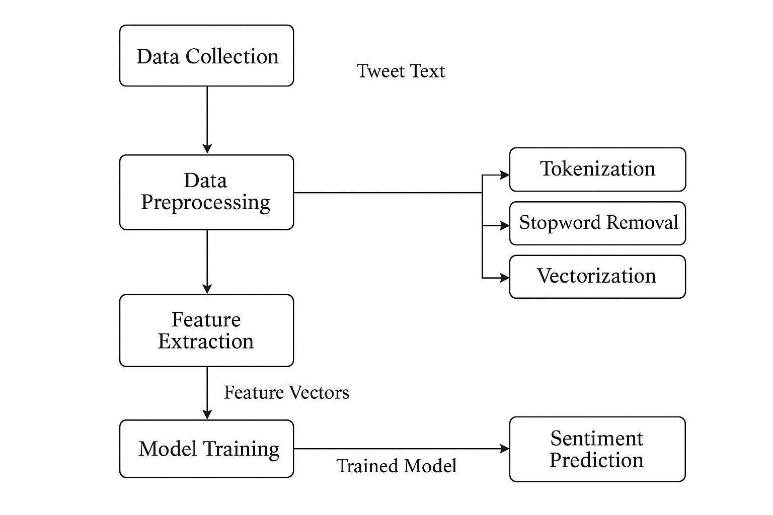
Level 2 DFD
- Describes the detailed flow inside each subprocess.
- For example, in Data Preprocessing, the data passes through steps such as tokenization, stopword removal, and vectorization before being used by the model.
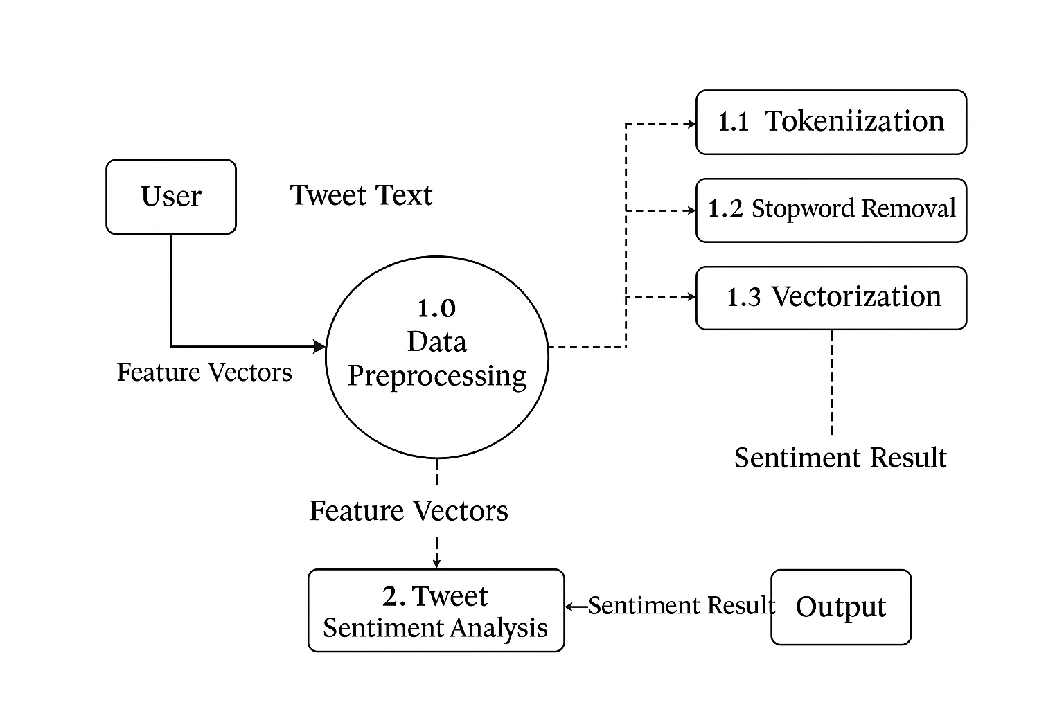
4.2 ENTITY RELATIONSHIP (ER) DIAGRAM
The Entity Relationship (ER) Diagram represents the logical structure of the database used in the project. Although sentiment analysis mainly uses text data, some structured data (like tweet IDs, sentiment labels, and timestamps) can be represented using an ER diagram.
Entities and Attributes:
- Tweet_Data (Tweet_ID, User_ID, Date, Tweet_Text)
- Processed_Data (Tweet_ID, Clean_Text, TF-IDF_Features)
- Model_Output (Tweet_ID, Predicted_Sentiment, Confidence_Score)
Relationships:
- Each Tweet_Data entry is linked to a Processed_Data record by Tweet_ID.
- Each Processed_Data record produces a Model_Output result after prediction.
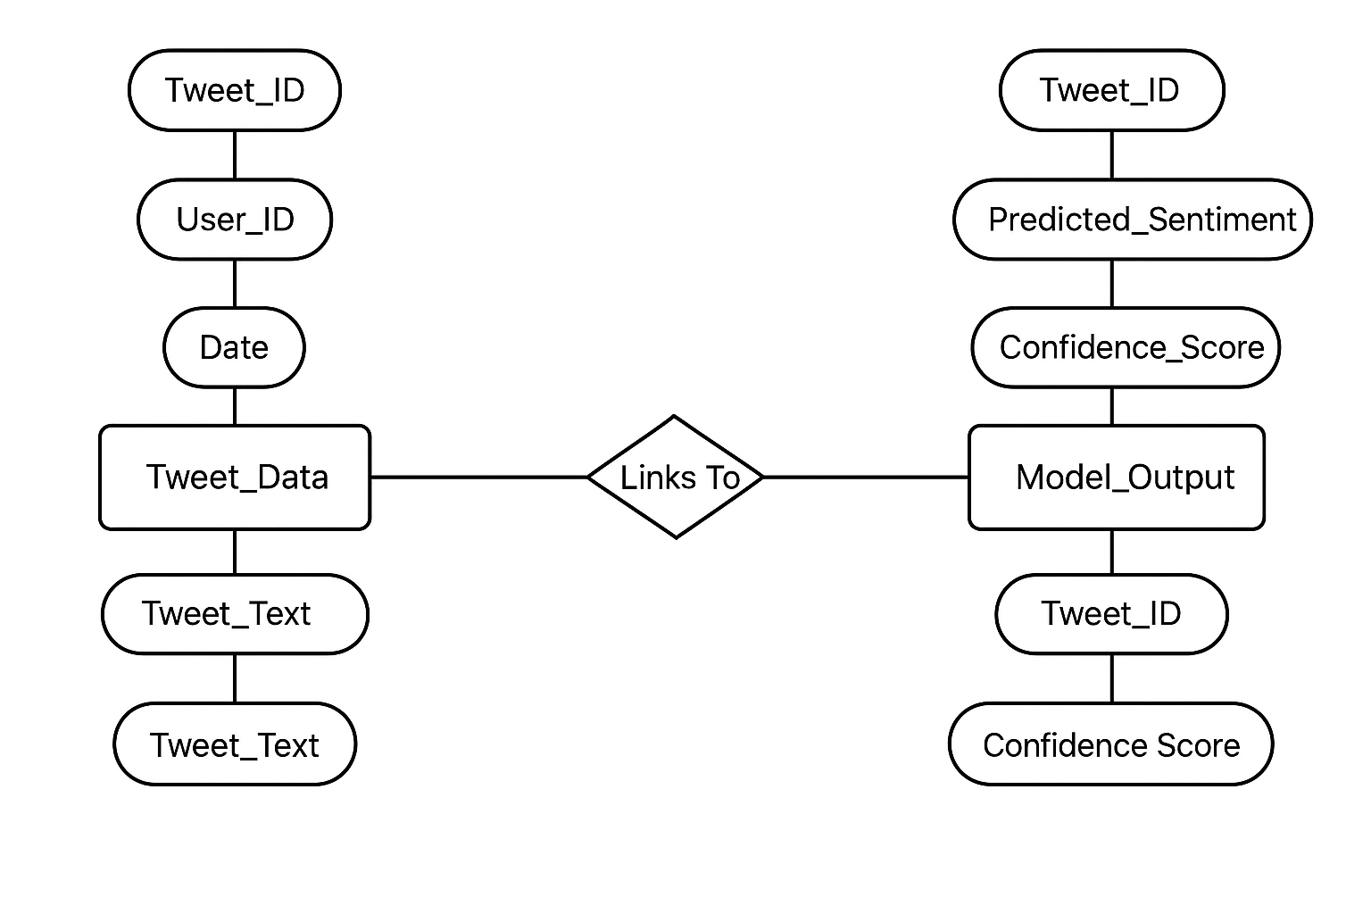

4.3 SYSTEM FLOW DIAGRAM (SFD)
The System Flow Diagram (SFD) provides a sequential view of how the system operates from start to finish. It shows the flow of control between the different functional modules of

Collect election-related tweets.

Preprocess data (cleaning, tokenization, stopword removal).

Extract features using TF-IDF.

Train the Support Vector Machine (SVM) model.

Test the model using unseen data.

Classify sentiments into Positive, Negative, or Neutral.

Display results and visualize sentiment distribution

4.4 TABLE DESIGN
The Table Design defines how data is organized and stored during the different stages of the project.
Although the main dataset is textual, it can be structured in tabular form for easier manipulation and analysis.
Table Name | Column Name | Data Type | Description
Tweet_Data | Tweet_ID | Integer | Unique ID for each tweet
 | User_Name | Varchar | Username of the tweet author
 | Tweet_Text | Text | The content of the tweet
 | Date | Date | Date of tweet creation
Processed_Data | Tweet_ID | Integer | Foreign key referencing Tweet_Data
 | Clean_Text | Text | Preprocessed text after cleaning
 | TFIDF_Vector | Array/Float | Numerical representation of text features
Model_Output | Tweet_ID | Integer | Foreign key referencing Tweet_Data
 | Predicted_Sentiment | Varchar | Model’s output label (Positive/Negative/Neutral)
 | Confidence_Score | Float | Probability score of the prediction
This table structure ensures smooth data flow across different phases of sentiment analysis, from collection to final prediction and visualization.

5. TESTING
Testing is an essential part of any software development or data analysis process. It ensures that the system functions correctly, produces reliable results, and meets the specified requirements. In this project, testing focuses on validating the accuracy, stability, and efficiency of the Support Vector Machine (SVM) model used for sentiment classification. The testing process also ensures that data preprocessing, feature extraction, and model evaluation modules are working as intended.
5.1 TESTING METHODOLOGIES
To ensure the proper functioning of the sentiment analysis system, various testing methodologies were applied as part of the development cycle.
1. Unit Testing
Unit testing was performed on individual modules such as data preprocessing, feature extraction, and model training. This helps identify errors in specific functions like text cleaning, tokenization, and feature vector generation.
2. Integration Testing
After verifying each module independently, integration testing was carried out to check the flow of data between modules. For example, ensuring that the output from the TF-IDF feature extraction module is correctly passed to the SVM model for training and prediction.
3. Validation Testing
Validation testing was conducted to confirm that the system produces the desired sentiment classification outputs. The SVM model was tested using unseen (test) data to evaluate its generalization and reliability.
4. Performance Testing
The performance of the model was evaluated using standard machine learning metrics such as:
- Accuracy: Measures overall correctness of predictions.
- Precision: Determines the proportion of positive identifications that were actually correct.
- Recall: Measures the ability of the model to find all relevant instances.
- F1-Score: A balanced measure that considers both precision and recall.
The SVM classifier achieved high accuracy, demonstrating that it is a suitable model for sentiment analysis on social media data.

6. IMPLEMENTATION
Implementation is the stage where the designed and tested system is developed into a working model. For this project, implementation was done using Python in Jupyter Notebook, utilizing libraries such as pandas, numpy, scikit-learn, matplotlib, and nltk for data handling, machine learning, and visualization.
The project was implemented step by step to ensure correctness, modularity, and clarity. Each phase—from data preprocessing to visualization—was carefully executed and tested.
6.1 MODULES AND ITS DESCRIPTIONS (WITH SCREENSHOTS)
Module 1: Data Collection
- Tweets related to the US Election 2022 were collected from open-source datasets and social media APIs.
- The data was stored in CSV format for easy access and manipulation.
- Each record contains tweet text, timestamp, and metadata.
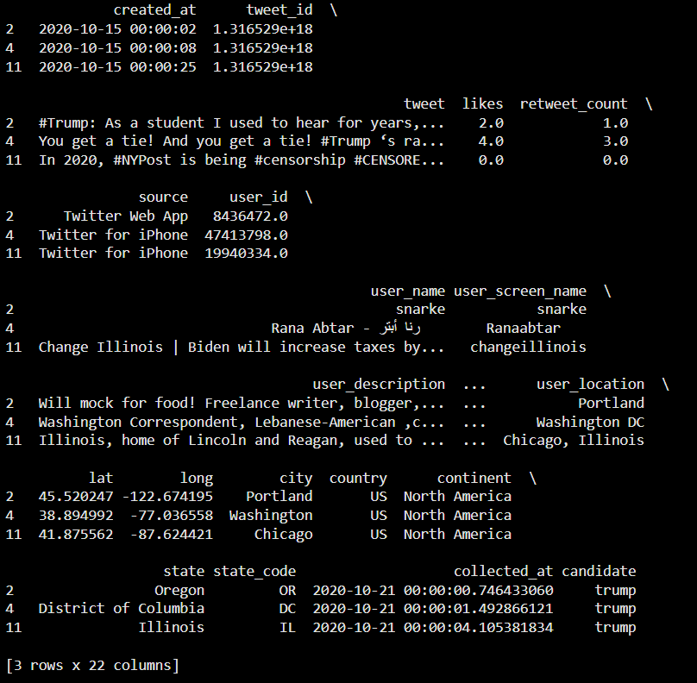
Module 2: Data Preprocessing
- Data preprocessing involved cleaning and preparing the text for analysis.
- Steps included removing punctuation, links, hashtags, stopwords, and converting all text to lowercase.
- Tokenization and stemming were applied to standardize words.
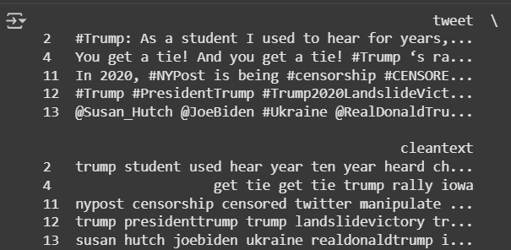
Module 3: Feature Extraction
- The TF-IDF Vectorizer was used to convert text data into numerical vectors.
- This step transforms words into measurable features suitable for machine learning algorithms.
Module 4: Model Training and Testing
- The preprocessed data was split into training and testing sets.
- The Support Vector Machine (SVM) model was trained using the training data and tested on the remaining data.
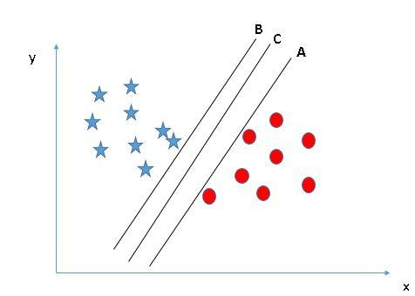
- Different kernel types (Linear, RBF, Polynomial) were compared to determine the most efficient
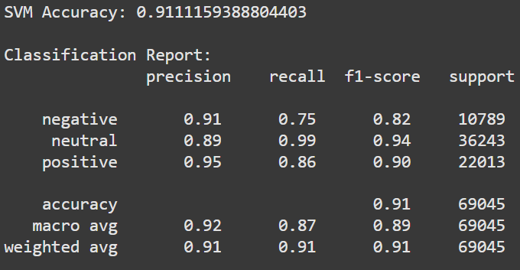
Module 5: Evaluation and Visualization
- The model’s performance was evaluated using accuracy, precision, recall, and F1-score metrics.
- Confusion matrix and visualization graphs were created to interpret model results effectitely.
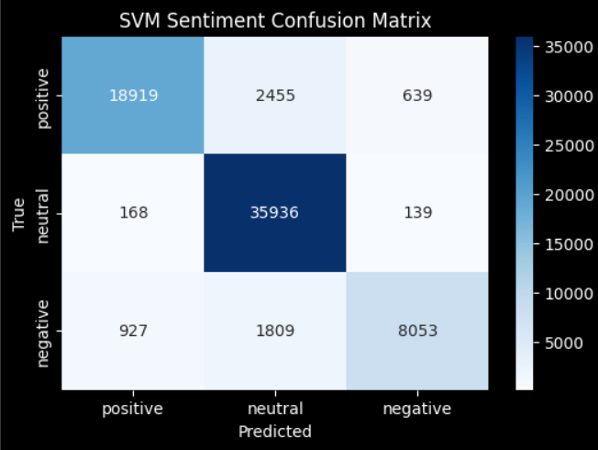
Module 6: Sentiment Prediction
- The final trained model predicts whether a tweet expresses a Positive, Negative, or Neutral sentiment.
- Visualization charts summarize the overall sentiment distribution among tweets.

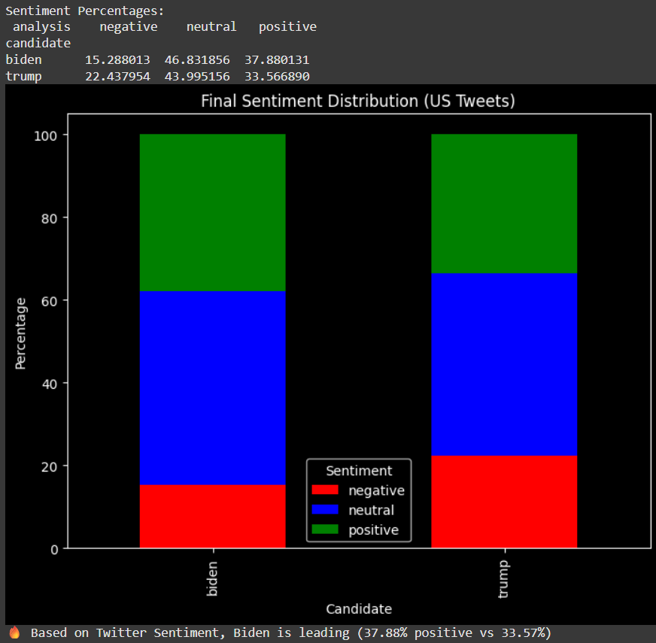

7. CONCLUSION AND FUTURE ENHANCEMENT
Conclusion
The project titled “Sentiment Analysis on US Election 2022 using SVM Model” demonstrates the effective use of machine learning and natural language processing (NLP) techniques to analyze public opinions expressed on social media platforms. Through this project, a systematic approach was implemented to collect, clean, preprocess, and analyze a large set of tweets related to the 2022 US Election. The Support Vector Machine (SVM) algorithm was employed to classify sentiments into positive, negative, and neutral categories.
The preprocessing steps, including removal of stopwords, URLs, and unwanted characters, played a significant role in improving data quality and model performance. The TF-IDF vectorization technique converted text into numerical features suitable for the SVM classifier. The model achieved a high level of accuracy and reliability, proving that SVM is an excellent choice for text classification tasks involving high-dimensional and sparse data. The evaluation metrics such as accuracy, precision, recall, and F1-score confirmed the robustness and efficiency of the proposed system.
This project also highlights the importance of sentiment analysis in understanding the collective opinions of people during major political events. By identifying public sentiment trends, the system can help researchers, media organizations, and political analysts make informed decisions. Overall, the project successfully meets its objectives and showcases how machine learning can be applied to real-world data analysis problems, bridging the gap between academic learning and practical implementation.
Future Enhancement
Although the system performs effectively for static datasets, there is still scope for further improvement and expansion. Some of the potential future enhancements include:
- Real-Time Data Analysis: Integrating APIs (such as Twitter API) to collect and analyze live tweets dynamically.
- Deep Learning Models: Using advanced neural network architectures like LSTM, BERT, or Transformers to enhance contextual understanding and accuracy.
- Multilingual Sentiment Analysis: Extending the model to support multiple languages for broader global applicability.
- Visualization Dashboard: Developing a web-based dashboard using Streamlit or Tableau for real-time visualization of sentiment trends.
- Topic Classification: Enhancing the system to not only classify sentiment but also identify specific topics or issues being discussed.
- Hybrid Model Approach: Combining SVM with deep learning or ensemble techniques to improve predictive performance further.
By incorporating these improvements, the system can evolve into a comprehensive, real-time sentiment analysis platform capable of providing deep insights into public opinion trends across multiple domains.

BIBLIOGRAPHY
- Bird, S., Klein, E., & Loper, E. (2009). Natural Language Processing with Python. O’Reilly Media.
- Russell, M. A. (2013). Mining the Social Web: Data Mining Facebook, Twitter, LinkedIn, Instagram, GitHub, and More. O’Reilly Media.
- Jurafsky, D., & Martin, J. H. (2020). Speech and Language Processing (3rd ed.). Pearson.
- Twitter Developers. (2020). Twitter API Documentation. Retrieved from https://developer.twitter.com/en/docs
- Pedregosa, F., Varoquaux, G., Gramfort, A., Michel, V., Thirion, B., Grisel, O., … & Duchesnay, É. (2011). Scikit-learn: Machine Learning in Python. Journal of Machine Learning Research, 12, 2825–2830.
- Loria, S. (2018). TextBlob: Simplified Text Processing. Retrieved from https://textblob.readthedocs.io/en/dev/
- Bird, S. (2006). NLTK: The Natural Language Toolkit. In Proceedings of the COLING/ACL on Interactive Presentation Sessions (pp. 69–72). Association for Computational Linguistics.
- McKinney, W. (2017). Python for Data Analysis: Data Wrangling with Pandas, NumPy, and IPython (2nd ed.). O’Reilly Media.
- Al-Moslmi, T., Khalid, S., & Al-Khalifa, H. (2019). Sentiment Analysis of Social Media Data Using Machine Learning Techniques. International Journal of Advanced Computer Science and Applications, 10(5), 289–296.
- Abbasi, A., & Chen, H. (2008). A Comparison of Machine Learning Techniques for Twitter Sentiment Analysis. In Proceedings of the 2nd International Conference on Social Computing (pp. 437–442). IEEE.
- Streamlit Documentation. (2023). Build and Share Data Apps in Python. Retrieved from https://docs.streamlit.io/
- Seabold, S., & Perktold, J. (2010). Statsmodels: Econometric and Statistical Modeling with Python. In Proceedings of the 9th Python in Science Conference.

8. APPENDIX
!pip install nltk wordcloud textblob
import nltk
nltk.download('omw-1.4')
nltk.download('stopwords')
nltk.download('wordnet')
import pandas as pd
import numpy as np
import matplotlib.pyplot as plt
import plotly.express as px
import re
from nltk.corpus import stopwords
from nltk.stem import WordNetLemmatizer
from textblob import TextBlob
from wordcloud import WordCloud, STOPWORDS
import seaborn as sns
import warnings
from sklearn.svm import SVC
warnings.filterwarnings('ignore')
trump = pd.read_csv("hashtag_donaldtrump.csv", lineterminator='\n')
biden = pd.read_csv("hashtag_joebiden.csv", lineterminator='\n')
trump['candidate'] = 'trump'
biden['candidate'] = 'biden'
data = pd.concat([trump, biden])
data.dropna(inplace=True)
data['country'] = data['country'].replace({
'United States of America': "US",
'United States': "US"
})
print("Final Data Shape:", data.shape)
print(data.head(3))
fig = px.bar(
data.groupby('candidate')['tweet'].count().reset_index(),
x='candidate', y='tweet', color='candidate',
title='Tweets per Candidate'
).update_layout(
plot_bgcolor='black', paper_bgcolor='black',
font=dict(color='white')
)
fig.show()
fig = px.bar(
data.groupby('candidate')['likes'].sum().reset_index(),
x='candidate', y='likes', color='candidate',
title='Comparison of Likes'
).update_layout(
plot_bgcolor='black', paper_bgcolor='black',
font=dict(color='white')
)
fig.show()
fig = px.bar(
data.groupby('country')['tweet'].count().sort_values(ascending=False).reset_index().head(10),
x='country', y='tweet',
title='Top 10 Countries Tweet Counts'
).update_layout(
plot_bgcolor='black', paper_bgcolor='black',
font=dict(color='white')
)
fig.show()
stop_words = set(stopwords.words('english'))
lm = WordNetLemmatizer()
def clean(text):
text = re.sub(r'https?://\S+|www\.\S+', '', str(text)) # remove URLs
text = text.lower()
text = re.sub('[^a-z]', ' ', text) # keep only letters
words = text.split()
words = [lm.lemmatize(word) for word in words if word not in stop_words]
return ' '.join(words)
data['cleantext'] = data['tweet'].apply(clean)
def getpolarity(text): return TextBlob(text).sentiment.polarity
def getsubjectivity(text): return TextBlob(text).sentiment.subjectivity
def getAnalysis(score):
if score < 0: return 'negative'
elif score == 0: return 'neutral'
else: return 'positive'
print(data[['tweet','cleantext']].head())
data['polarity'] = data['cleantext'].apply(getpolarity)
data['analysis'] = data['polarity'].apply(getAnalysis)
trump_tweets = data[(data['candidate'] == 'trump') & (data['country'] == 'US')]
plt.style.use('dark_background')
(trump_tweets['analysis'].value_counts(normalize=True)*100).plot.bar(color=['orange','blue','red'])
plt.title("Trump Sentiment Distribution (TextBlob)")
plt.show()
def word_cloud(wd_list):
stopwords = set(STOPWORDS)
all_words = ' '.join(wd_list)
wordcloud = WordCloud(background_color='black',
stopwords=stopwords,
width=1600, height=800, max_words=100).generate(all_words)
plt.figure(figsize=(12, 10))
plt.axis('off')
plt.imshow(wordcloud)
word_cloud(trump_tweets['cleantext'][:5000])
X = data['cleantext']
y = data['analysis']
from sklearn.model_selection import train_test_split
X_train, X_test, y_train, y_test = train_test_split(X, y, test_size=0.2, random_state=42)
from sklearn.feature_extraction.text import TfidfVectorizer
tfidf = TfidfVectorizer(stop_words='english', max_features=2500)
X_train_tfidf = tfidf.fit_transform(X_train)
X_test_tfidf = tfidf.transform(X_test)
from sklearn.svm import LinearSVC
svm_model = LinearSVC()
svm_model.fit(X_train_tfidf, y_train)
y_pred = svm_model.predict(X_test_tfidf)
from sklearn.metrics import classification_report, accuracy_score, confusion_matrix
print("SVM Accuracy:", accuracy_score(y_test, y_pred))
print("\nClassification Report:\n", classification_report(y_test, y_pred))
cm = confusion_matrix(y_test, y_pred, labels=['positive','neutral','negative'])
plt.figure(figsize=(6,4))
sns.heatmap(cm, annot=True, fmt='d', cmap="Blues",
xticklabels=['positive','neutral','negative'],
yticklabels=['positive','neutral','negative'])
plt.title("SVM Sentiment Confusion Matrix")
plt.xlabel("Predicted")
plt.ylabel("True")
plt.show()
us_data = data[data['country'] == 'US']
# Sentiment percentage for each candidate
sentiment_summary = us_data.groupby(['candidate','analysis'])['tweet'].count().reset_index()
sentiment_summary = sentiment_summary.pivot(index='candidate', columns='analysis', values='tweet').fillna(0)
# Convert counts to percentages
sentiment_summary_percent = sentiment_summary.div(sentiment_summary.sum(axis=1), axis=0) * 100
print("Sentiment Percentages:\n", sentiment_summary_percent)
# Bar plot (stacked sentiment comparison)
sentiment_summary_percent.plot(kind='bar', stacked=True, figsize=(8,6),
color=['red','blue','green'])
plt.title("Final Sentiment Distribution (US Tweets)")
plt.ylabel("Percentage")
plt.xlabel("Candidate")
plt.legend(title="Sentiment")
plt.show()
positive_trump = sentiment_summary_percent.loc['trump','positive']
positive_biden = sentiment_summary_percent.loc['biden','positive']
if positive_trump > positive_biden:
print(f" Based on Twitter Sentiment, Trump is leading ({positive_trump:.2f}% positive vs {positive_biden:.2f}%)")
elif positive_biden > positive_trump:
print(f" Based on Twitter Sentiment, Biden is leading ({positive_biden:.2f}% positive vs {positive_trump:.2f}%)")
else:
print(" It's a tie based on Twitter Sentiment!")

Output
